Introduction

This document will walk you through the process of downloading the Enterprise Project Management 2007 Demo Virtual Machine (VM) and associated resources via Microsoft’s Extranet Service.

In the past we have chosen to burn VMs to DVDs and distribute to the partner network. In the future, we intend to distribute large files via Microsoft’s Extranet Service. In order to access content / shares on the Extranet you will need to establish a partner account. Once the partner account has been created we will be able to associate this account with the content we wish to share with you. In the future this delivery vehicle will help us to share more content with the partner community in a timely manner.

The Enterprise Project Management 2007 Demo VM is designed to allow you to demonstrate the features and functionality of Microsoft Office Project 2007, Microsoft Office Project Server 2007, and Microsoft Office Project Portfolio Server 2007 in a live environment utilizing a single PC or laptop computer. In order to do so, it is necessary to run the software on a single machine using Microsoft Virtual PC 2007 or Microsoft Virtual Server 2005 R2. We tested the VM using latest versions of Microsoft virtualization technology; it is recommended that you also use the latest versions for best performance and reliability. Both desktop and server virtualization is available for free download from the Microsoft website.

Microsoft virtualization products allow you to utilize complex software systems without having to go through a lengthy installation and configuration process. As a result, you may notice that the demonstration software runs somewhat slower than the full product would in a production environment, and we encourage you to set appropriate expectations with your audience.

The Enterprise Project Management 2007 Demo has the RTM versions of the Project 2007 stack installed and configured plus the new Project Server and Portfolio Server demo databases. Demo scripts are included with this image, more will be posted at a later date. There is an instruction document to describe the role and logins of the users.

The contents of the VM are:
- Windows Server 2003 R2
- Microsoft SQL 2005 SP2
- Microsoft SQL 2005 Analysis Services SP2
- Microsoft SQL 2005 Reporting Services SP2
- Microsoft Office Project Server 2007
- Microsoft Office Project Portfolio Server 2007
- Microsoft Office SharePoint Server 2007
- Microsoft Office Enterprise 2007
- Microsoft Office Project Professional 2007
- Microsoft Office Visio 2007
- .Net Framework 3.0
The image is 3.5 GB and we recommend that you have about 13GB of free disk space in order to install and run. We broke the installation into eight pieces to facilitate an easier download.

Office EPM Solution 2007 VM Download Process

Step 1: Requesting a Partner Account

- To request the creation of the partner account send an email to proj2007@microsoft.com (note: add EPM 2007 VM Download Request to the subject line)

- Provide the following details in the email body
  - First Name
  - Surname
  - Telephone Number
  - Partner Company Name
  - Partner Status (e.g. Member, Certified etc.)
  - Country

If you already have an account created, please go to step 3

- Upon receipt of your request a partner account will be created within 72 hours.

Step 2: Registering Your Partner Account

- It may take 30 minutes or so for your credentials to update in our databases and once this is complete, you will receive the following automated emails:

  - Welcome to the Microsoft Extranet Home (from EPP@microsoft.com). This email lists a number of steps to register your partner account.
  - Pin Number (from a-niamhm@microsoft.com). This email will contain a Pin number that you will need during the registration process.

- Follow the 4 steps listed in the Welcome to the Microsoft Extranet Home email:
  - Step 1: Click on the URL to become Certified User
  - Step 2: Verification Process
  - Step 3: Activating Microsoft Partner Account
  - Step 4: Complete Registration Process

(Note: Please complete the steps above within 7 business days of receiving this mail – otherwise, the PIN will expire, and we need to re-activate the partner account)

- After completing the registration you will receive the following emails:

  - Registration Completed Successfully (from EPP@microsoft.com)
  - User Status Has Been Changed (from EPP@microsoft.com)

Congratulations, you have successfully registered your Partner Account

Step 3: Install the JetStream Client on your Local Machine

- Since we will be downloading a large VPC image you will need to use a data transfer client (called “JetStream”). To install the JetStream client on your local machine please select the appropriate link below:

- In United States: https://usjs.partners.extranet.microsoft.com/jetstream/client/setup
- In Europe:https://eujs.partners.extranet.microsoft.com/jetstream/client/setup
- In East Asia: https://eajs.partners.extranet.microsoft.com/jetstream/client/setup

- When prompted for network id and password, type your PARTNERS username and password.

Step 4: Downloading the Enterprise Project Management 2007 VM

- In the JetStream client click on the Tools link in the main menu bar and select the Connect and JetStream location options in the sub-menus:

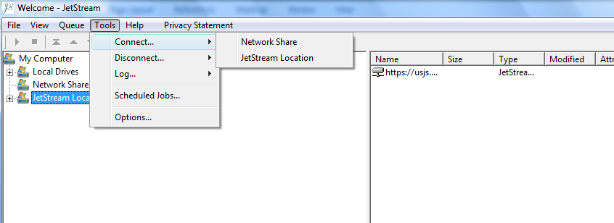

- In the JetStream Connect JetStream Location pop-up window add the following url
https://usjs.partners.extranet.microsoft.com/us20/EPM Solution 2007 VPC Apr 07

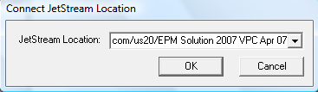

- Add your username and password when prompted : For example:

  - Username = Partners\CCrozier
  - Password = ***********

- You should now be able to connect to EPM Solution 2007 VPC Apr 07 download share by drilling down within the directory structure (expand the JetStream locations node). The following folder is displayed in the share:

  - EPM Solution Demo VPC files – (contains the setup.exe for the EPM 2007 VPC)

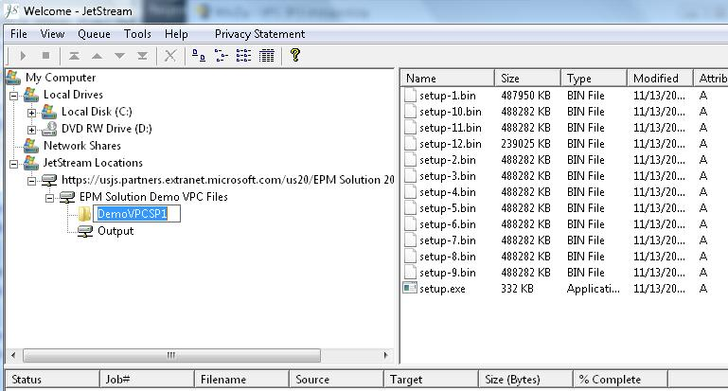

The Output folder contains the original VPC (no service pack 1 beta preview).

- You can now use the JetSteam client to transfer the files from the share onto your local machine:

  - Transferring the EPM 2007 Demo Image:
    - Open the EPM Solution Demo VPC folder
    - Open the DemoVPCSP1 folder
    - Select the files within the folder
    - Drag the files to the appropriate location on your local machine (Note: You have to drag and drop the flies within the JetStream Client directory)

(Note: The download will take between 2 – 5 hours depending on your connection speed)

Step 5: Installing the Enterprise Project Management 2007 Demo Image

- Run the setup.exe from the download. It will expand all the necessary files.

